 |  |  | Private Practices  Anderson Hospital 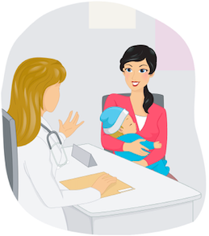     6800 State Route 162, Maryville, IL 62025 Phone: 618-391-6057  Kelly Houston 2023 Vadalabene Drive, Suite 200, Maryville, IL 62062 Phone: 618-288-7408 x 228  Dee Kassing Breastfeeding Support Services, Inc. Collinsville, IL 62234 Phone: 618-346-1919  Alisa Williams Momentum Wellness and Learning 201 Hillsboro Ave, Edwardsville, IL 62025 Phone: 618-406-6372  Online resources  www.edwardsvilleregionbreastfeeding.org  http://illinoisbreastfeeding.org/20873.html |  | Edwardsville Region Breastfeeding Task Force  Established Since 1985  Resource Guide  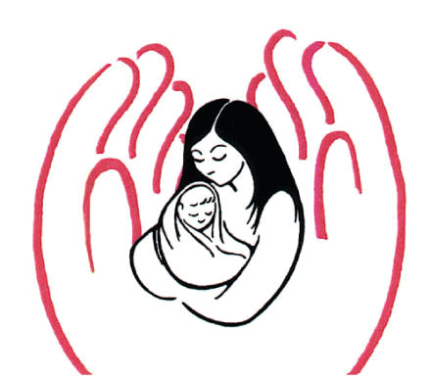  302 Chesapeake Lane, Collinsville, IL 62234  618-346-1919    https://edwardsvilleregionbreastfeeding.org/  Compiled by  SIUE Nutrition & Dietetics Students 2021
  Breastfeeding Resource Guide
  Compiled by Emma Brown & Aubrey Kamp
  SIUE Nutrition & Dietetics Graduate Students
π

Pump Rentals & Supplies
Lactation Station at Anderson Hospital 6800 State Route 162 Maryville, IL 62025 Phone: 618-391-6057
Dee Kassing Breastfeeding Support Services, Inc. Collinsville, IL 62234 Phone: 618-346-1919
Medicate Pharmacy & DME 100 N. 8th Street, East St. Louis, IL 62201 Phone: 618-875-1000
1833 Kingshighway, Washington Park, IL 62204 Phone: 618-874-3000
5869 Bond Ave, Centreville, IL 62206 Phone: 618-500-2900
2166 Madison Ave, Granite City, IL 62040 Phone: 618-451-2000
DME-After Hours 1-888-338-6495

Pregnancy Care Center 108 S. 3rd Street, Suite 50, Belleville, IL 62226 Phone: 618-223-2273
SIHF: Healthy Start Program 6000 Bond Ave, Centreville, IL 62206 Phone: 618-646-2505
2001 State St., East St. Louis, IL 62201 Phone: 618-646-2505
100 N. 8th St., East St. Louis, IL 62201 Phone: 618-646-2505
7210 W. Main, Belleville, IL 62226 Phone: 618-646-2505

Breast Milk Depots
Clinton County Health Department-WIC 930 A Fairfax Street, Carlyle, IL 62231 Phone: 618-594-8942
Coordinated Youth & Human Services-WIC 2016 Madison Ave, Granite City, IL 62040 Phone: 618-877-3433

: Breastfeeding Supplies & Rentals : Education Consultations : Breastfeeding Classes : Breastfeeding Support Groups : Health Insurance

Hospitals
Alton Memorial Hospital #1 Memorial Dr, Alton, IL 62002 Phone: 618-463-7538
Anderson Hospital 6800 State Route 162, Maryville, IL 62025 Phone: 618-391-6050
Memorial Hospital East 1404 Cross Street, Shiloh, IL 62269 Phone: 618-607-3300
St. Elizabeth’s Hospital # 1 St. Elizabeth’s Blvd, O’Fallon, IL 62269 Phone: 618-234-2120 x 31925
St. Joseph’s Hospital 9515 Holy Cross Lane, Breese, IL 62230 Phone: 618-526-5423
Randolph County Health Department WIC 2515 State Street, Chester, IL 62233 Phone: 618-826-5007
211 Hasle Street, Sparta, IL 62286 Phone: 618-443-2995
St. Clair County Health Department WIC 19 Public Sq, Suite 150, Belleville, IL 62220 Phone: 618-806-4686
Washington County Health Department WIC 177 S. Washington, Nashville, IL 62263 Phone: 618-327-3644

Support Centers
Bond County Breastfeeding Support Group 7 Whippoorwill Dr, Greenville, IL 62246 Phone: 618-292-7307
Le Leche League Fairview Heights, IL 62208 Phone: 618-321-6667 or www.lllmetroeaststl.org
Life Network of Southern Illinois
722 N. Market St. Waterloo, IL 62298 Phone: 618-939-4224 324 N. Main St. Red Bud, IL 62278 Phone: 618-282-4225
Mosaic Pregnancy & Health Center 2019 Johnson Rd, Granite City, IL 62040 Phone: 618-451-2002 5016 N. IL St, Suite A, Fairview Heights, IL 62208 Phone: 618-407-0108

WIC - The Go-To Place For Breastfeeding Support!
Bond County Health Department 1520 South 4th Street, Greenville, IL 62246 Phone: 618-664-1442

Clinton County Health Department WIC 930 A Fairfax Street, Carlyle, IL 62231 Phone: 618-594-8942
Coordinated Youth & Human Services WIC 2016 Madison Ave, Granite City, IL 62040 Phone: 618-877-3433
101 E. Edwardsville Rd, Wood River, IL 62095 Phone: 618-254-3591
East Side Health District WIC 638 N. 20th Street, East St. Louis, IL 62201 Phone: 618-874-4713
1274 Camp Jackson Rd, Cahokia, IL 62206 Phone: 618-337-4178
2568 N. 41st Street, Fairmont City, IL 62201 Phone: 618-271-7550
Jersey County Health Department WIC 1307 State Hwy 109, Jerseyville, IL 62502 Phone: 618-498-9565
Macoupin County Health Department WIC 1115 Morgan Street, Carlinville, IL 62626 Phone: 217-854-7272
Monroe County Health Department WIC 1315 Jamie Lane, Waterloo, IL 62298 Phone: 618-939-3871

This Institution is an Equal Opportunity Provider.
Randolph County WIC 2515 State Street, Chester, IL 62233 Phone: 618-826-5007
211 Hasle Street, Sparta, IL 62286 Phone: 618-443-2995
Washington County WIC 177 South Washington, Nashville, IL 62263 Phone: 618327-3644
Monroe County WIC 1315 Jamie Lane, Waterloo, IL 62298 Phone: 618-939-3871

